1. Create an API Key and Secret in Octane. Assign the key to access the workspace you want to generate the report. Viewer group should be fine.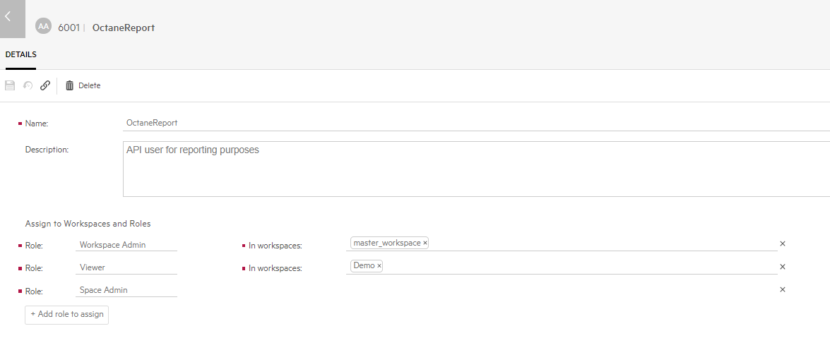
2. Bring up the Excel macro.
3. Enter the Octane server information

Example:

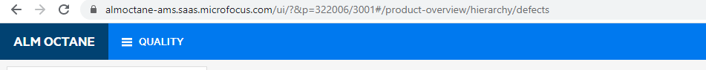

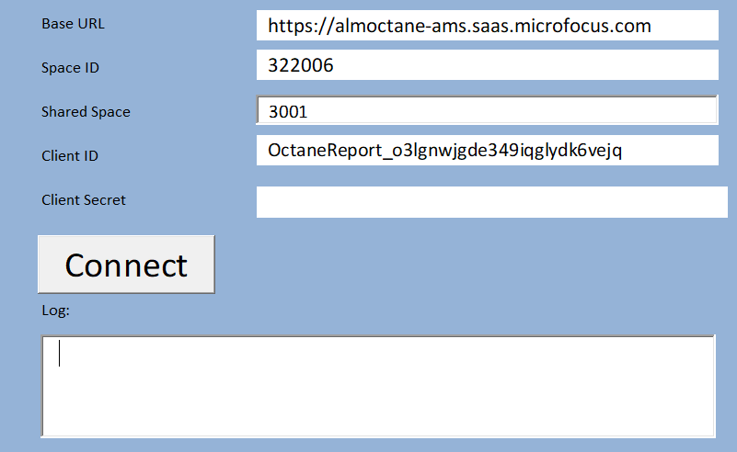

1. Click on “Connect” button to generate the report.
2. Navigate to the “manual tests” tab to review the report.

